**Brooklyn torah gazette**

**For parshas Beshalach 5782**

Volume 6, Issue 17 (Whole Number 272) 13 Shevat 5782/ January 15, 2022

**Printed L’illuy nishmas Nechama bas R’ Noach, a”h**

For a free subscription, please forward your request to [***keren18@juno.com***](mailto:keren18@juno.com)

**Lessons To Learn From**

**The Chaim Walder Tragedy**

**By**[**Rabbi Ron Yitzchok Eisenman**](https://www.jewishpress.com/author/rabbi-ron-yitzchok-eisenman/)



**Rabbi Ron Yitzchok Eisenman**

The smoke has settled somewhat since the shocking conflagration caused by allegations of severe and ongoing sexual abuse by Chaim Walder became public knowledge.

Many good rabbis have already weighed in on the matter.

Even before the *beis din*of Rav Shmuel Eliyahu met, after the allegations were printed in *Haaretz*, Rabbis Yehuda Silman and Sariel Rosenberg of the *beis din*of Rav Nissim Karelitz had issued a ruling stating it is inappropriate to read his books.

Similarly, the *Yated Ne’eman* removed his column immediately after the allegations published in Haaretz became known.

Likewise, his popular radio show on Kol Chai was canceled. His stories would no longer appear in the weekly publication of *Hidabrut*, a popular chareidi kiruv organization in Israel, and were excised from a religious Zionist children’s magazine, “*Otiot V’Yaladim*.”

The fact that all of these organizations pulled his writings and prevented him from speaking on the radio speaks volumes.

**The “Best” and “Worst” Case Scenarios**

Obviously, in the “best” case scenario, they felt the allegations were serious enough to act on them immediately. In the “worst” case scenario, they felt this was just the tip of the iceberg as rumors against him had been circulating for years.

In December, Rav Eliyahu convened a rabbinic court headed by himself and the two other judges, Rav Reuvain Maker and Rav Aharon Yarchi. Walder was summoned to appear and refused.

As Rav Yosef Sholom Elyashiv and Rav Yitzchok Zilberstein, and Rav Moshe Sternbuch have said in the past, you do not require witnesses to issue a public warning.

If a *beis din*, or even a qualified single rav, after hearing the allegations, (even in the absence of the accused), concludes that there are *reglayim l’davar*, namely, the accusations are credible, they must publicize the accused’s name to protect others.

There is no *lashon hara*when one is protecting others. Why is this so difficult to accept?

**Imagine if Your Son or Daughter would Call You**

Can you imagine if your son or daughter would call you from the therapist’s office and tell you that the therapist had sexually abused them, and your child asks you what they should do?

Would you answer, “That’s *lashon hara.*So and so has a *chezkas kashrus* and a *beis din*has not decided he is bad, so continue with the session”?

Twenty-two separate witnesses, covering a span of 25 years, laid out a reign of terror directed against boys, girls, single women, and married women. If that is not *raglayim l’davar*, then what is?

To the best of my knowledge, no one of any stature has denied Walder’s guilt. Rather, the focus has shifted to the methodology employed in stopping him.

As Rav Shmuel Eliyahu has made clear – only after consultation with rabbonim in Bnei Brak – the decision was reached that the only way to stop this addicted predator was to publicly defrock and reveal the allegations leveled against him.

Rav Eliyahu pleaded with Walder to cooperate; he refused.

Even his suicide was not the act of a hopeless person; rather, it was the calculated conclusion of a control freak who made sure, just as he controlled others in life, he would continue to control others in his death.

[](https://www.jewishpress.com/wp-content/uploads/Eisenman-010722.jpg)

He openly admits on recordings that if he cannot wriggle out of the charges (which he does not deny in the recordings) he will kill himself; and so he did.

Therefore, the probability of the truthfulness of the allegations is undeniable. Those who continue to deny live in a world of denialism where white is black and black is white.

Now that Walder has committed suicide, ensuring he will never harm others and his reign of terror and destruction has ceased, the question arises: What should we do now?

We must not waste this unfortunate and painful episode by sweeping it under the rug.

Certainly, we must rid our homes of his writings.

As Rabbi Silman and Rosenberg wrote, “Reading his books is then akin to supporting the acts of which he has been accused.”

Yet that is not enough.

First and foremost, we must start acknowledging and validating the victims of sexual abuse. As Rav Asher Weiss wrote, “Sexual abuse is often so horrific and damaging that the victims bear the scars forever.”

**They Deserve our Support and our Love**

We must thank the brave victims who came forward. Notwithstanding the lack of complete communal support, they stood tall and bold and told their painful stories to save others from the cruel clutches of this ruthless destroyer of Jewish souls. They are our heroes, and they deserve our support and our love.

We must be vigilant in overseeing anyone who has access to children. We must educate and reeducate our children that no one has the right to touch them, and anything uncomfortable that happens to them, they should feel comfortable telling others.

They will not be judged or chastised, and their words will be taken seriously.

There are those who want to live in denial and continue to defend the predator. They have never met Walder; rather, they feel devastated and betrayed. Since it is emotionally uncomfortable to believe that a person you respected and helped raise your children was, in reality, a sexual predator, a person may choose to deny the entire episode. This is a very convenient and easy way out.

One can always rely on cherry-picking a halacha from the Chofetz Chaim to shut their eyes and close their ears.

Although this is understandable, it is symptomatic of the superficiality of their belief system.

**The Torah is Full of Great People Who Did Bad Things**

The Torah is full of great people who did bad things. People can and do sin. We must accept this and strengthen ourselves.

We must strengthen our belief that Hashem is sending us a learning moment.

It is a time for us to reevaluate our attitude toward victims of sexual abuse and be extremely vigilant in the safety of our children.

We can use this unfortunate episode to grow and improve ourselves in helping stamp out sexual abuse and assisting those who have already been victimized by it.

Or we can live in denial and pretend nothing happened.

The choice is ours.

*Reprinted from the January 5, 2022 email of the JewishPress.com from a letter released by Rabbi Ron Yitzchok Eisenman on December 29, 2021, who has since 1997 been the rav of Congregation Ahavas Israel in Passaic, New Jersey. He is the author of the book, “The Elephant in the Room,”*

**Rabbi Berel Wein**

**On Parshas Beshalach**



If a person lights even a small candle in a dark room, the resultant light is instantaneously recognizable. Even the flickering of the smallest of candle shines brightly in an enclosed space that is dark. However, if one is to light even a large candle in a room filled with brilliant sunlight or an excess of artificial illumination, the light of that candle is hardly noticeable.

One can say the same idea regarding miracles. If one views a world full of ever-present miracles, then one individual miracle, no matter how powerful and supernatural it may be, will, at best, cause only a minor, temporary impression. The very definition of miracles is that these are events that do not often occur and are not predictable or subject to rational, scientific analysis.

However, when there is a plethora of miraculous events, miracles themselves, no matter how wondrous they may be, begin to lose their impact and power. A miracle that happens regularly is no longer a miracle at all, but, rather, is part of what people view as being the natural course of events in the world. Miracles that are repeated often eventually become stale and regular and lose their miraculous status.

Witness today's great wonders of nature, of medicine, of technology, and of all other fields that border on the miraculous. When the first rocket with a human inside was launched, it was considered miraculous. Today, it is a weekly event and nothing special for the spectator. The more an experience becomes regular and expected, the less any special quality is attached to it.

When there is a multiplicity of miracles occurring all at the same time, like the candle lit in a room with floodlights, its brightness is hardly noticeable. The individual miracle has lost its power of influence and is already discounted by human beings.

All of this is a preface to understanding the Jewish people after they experienced the Ten Plagues that delivered them from Egypt. The splitting of the sea that delivered them from the sword of the Pharaoh and his army was followed by the miraculous sweetening of the bitter waters in Marah and then the heavenly bread that was given to them for their sustenance. In that floodlit world of miracles, the flame of an individual miracle and its influence waned greatly.

This helps us understand the behavior of the Jewish people throughout their forty-year sojourn in the desert of Sinai. Everything was so miraculous that nothing was special any longer. What resulted was that the evil instinct of rebellion, arrogance and carnal desires continued to surface over and over throughout the Torah.

In our time, the rejuvenation of the Jewish people, the mass study of Torah, the creation and continued growth of the State of Israel in the land of Israel, are all events that border upon the miraculous and supernatural. Yet they, too, are not treated in that manner, for the recognition of miracles is difficult for human beings to maintain and preserve.

For forty years in the desert, the L-rd attempted to protect the Jewish people through heavenly intervention, but they did not understand or appreciate what was happening. They only complained. Our Rabbis teach: “One who is experiencing a miracle does not recognize the miracle that is happening at that moment.” And so, it is.

*Reprinted from this week’s website of rabbiwein.com*

# Rav Avigdor Miller on

# Women, Gemara and Gan Eden



**QUESTION:** **Why is it that it is not right for women to learn gemara?**

**ANSWER:** And the answer is, very simple. Because there is a very important principle in life and nobody should be a wise guy about it; everybody should fear what this ma’amar says: להתרחק מן הנשים – Keep far away from women. You just can’t help it. It’s human nature. And women should keep far away from man. הוי בורח מן העבירה כבורח מן האש — You have to run away from sin like you flee from fire.

Now, if a man will open a gemara and somebody, a female, passes by and she says, “Do you know, I have a kasha over here,” and they get into a discussion, he should know he is playing with fire. It starts out with Gemara and it ends up with Gehenim.

And not only that; even Mesilas Yesharim — let’s say you want to learn Mesilas Yesharim with a woman together, it is a messila that goes straight down into shiva medurei gehenim; there is no question about it. You can’t help yourself. Not because you are a sinful person; that is how Hakodosh Boruch Hu created the world.

Therefore, since people have to learn gemara and if women would do the same it would cause a very great, a very, very great disaster in the world, so Hakodosh Boruch Hu says, “Ladies, you want to learn? Learn Chumash.” It is a very important subject Chumash; so you stick to Chumash and people who learn Chumash they wouldn’t bother with you because the men usually go on to other things. Or if you want, you can learn tanach. You can learn things; there is plenty to learn. Just stay away from Gemara because Gemara is something that men have to do.

**Gemara Takes Up a Big Part of Your Spare Time**

Now, I will explain a little more. Gemara takes up a big part of your spare time and women can’t afford to give all that time because women work all day long. A man’s work is from sunrise to sunset usually, or from nine to five, but a woman’s work is all around the clock; they have to raise up families and they can’t afford to sit at the gemara – otherwise what would happen to the family? And therefore, whenever they get a chance, when they get a little crack in their schedule, they can get in something if they wish; there are plenty of good things to learn. But Gemara, anybody who knows anything about Gemara knows that it takes up a great deal of your time.

And therefore, Hakodosh Boruch Hu says to the women: “You will get reward in the next world for having beautiful children with good derech eretz and frum and as many as you can have.” And Hakodosh Boruch Hu will reward you; you will be a millionaire in the next world. Your husband is going to be jealous of you. You lived such a contentment-filled ride through existence – you had no problems. The ‘only’ problem is to raise your family in a kosher way. Of course, keep your mouth closed too; don’t talk too much – but that applies to everybody.

**They Go to Gan Eden More Readily than Men**

גדולה הבטחה שניתנה לנשים – How great is the promise that Hashem gave to women. He promises it to them more easily; they go to Gan Eden more readily than men. Whereas men have various kinds of problems; they fight sometimes over kavod – glory, who is a bigger lamdan. Oh yes! Competition in business, competition in the bais haknesses. Each one wants to be elected president and gabbai; all kinds of things happen among men. But the women are excused from that kind of competitive life.

And therefore, it’s not so easy to be a man. The only reason we make the bracha of shelo asani ishah, I always say, is because a man has pockets in his suit; women don’t have pockets. It’s such a blessing to have pockets! So, when you have pockets that’s why you can say shelo asani ishah – “Boruch Hashem, I have pockets!

*Reprinted from the January 2, 2022 email of Toras Avigdor (Tape 947)*

**The Important Role of the**

**Jewish Woman’s Anticipation**

**And Trust in the Promised Redemption**

**From the Talks of the Lubavitcher Rebbe**

**Rabbi Menachem Mendel Schneerson, Zt”l**



In this week's portion, Beshalach, we read the song of the Children of Israel led by Moshe after the splitting of the Sea of Reeds (Yam Suf) and the special song of the women led by Miriam the Prophetess.

In the Egyptian exile, it was Miriam who relayed the prophecy that a redeemer would emerge. Even when the leaders of that generation could not foresee an end to servitude and oppression, she spread hope and trust among her people.

**Questioned by Her Father about Her Prophecy**

When her mother was forced to place Moshe, the future redeemer of the Jews, in the Nile, her father Amram approached Miriam and asked her, "What will be the result of your prophecy? How will it be fulfilled?" Miriam remained at the banks of the Nile and "stood at a distance to know what would happen to him."

Our Sages explain that, in addition to her concern for her brother's future, she was concerned about the fate of her prophecy. How indeed would the redemption come about?

In a metaphorical sense, this narrative is relevant to all Jewish women, those living at present and those whose souls are in the spiritual realms. Concerned over the fate of the Jewish people, they anxiously await the Redemption.

The anxious anticipation of the redemption felt by Miriam -- and by all of the Jewish women in Egypt -- was paralleled in its intensity by their exuberant celebration when, after the miracles of the Sea, that redemption was consummated. After the men joined Moshe in song, the women broke out in song and dance, giving thanks to G-d with a spiritual rejoicing which surpassed that of the men.

The Torah's description of this celebration also testifies to the deep faith inherent in Jewish women.

**The Confidence of the Women Before Leaving Egypt**

The commentaries relate that as the women prepared to leave Egypt, they were so confident that G-d would perform miracles on behalf of their people in the desert that they took tambourines with them so they could rejoice when the time came.

In the very near future, we will celebrate the ultimate Redemption. We can now experience a foretaste of this impending celebration. Although we are still in exile, the confidence that the Redemption is an imminent reality should inspire us with happiness. For the Jewish people have completed all the Divine service necessary to bring the Redemption.

To borrow an analogy of our Sages, the table has already been set for the feast celebrating the Redemption, everything has been served, and we are sitting together with Moshiach. All that is necessary is that we open our eyes.

The experience of such happiness demonstrates the strength of our trust in the promise of the Redemption, and the expression of this faith will, in turn, hasten its realization.

*Reprinted from the Parshat Beshalach 5757/1997 edition of L’Chaim. Adapted from a talk of the Lubavitcher Rebbe, Shabbat Beshalach 5752-1992*

**Shtadlanim:**

**Dr. Jacob Birnbaum**

**By Sandy Eller**

[](https://jewishaction.com/content/uploads/2021/11/Birnbaum1-scaled.jpg)

**Dr. Jacob Birnbaum *(*Courtesy**

**of Yeshiva University Archives)**

Living as we are in 2021, it’s hard to believe that until not long ago, Orthodox Jews shied away from publicly advocating for particular issues, instead focusing all their efforts on behind-the-scenes diplomacy.

But that was exactly the case until 1964, the year that Dr. Jacob Birnbaum (1926-2014) chose to ignore the prevailing sentiment that organized campaigns could spark negative backlash and shone the spotlight on the plight of Soviet Jewry in a rather unconventional way.

Having grown up in London as a World War II refugee, Birnbaum knew even as a child about the carnage that was decimating European Jewry; his father’s job as a British government postal censor had him reading intercepted letters detailing the suffering and bloodshed that the Nazis tried to keep under the radar. Throughout his life, Birnbaum was haunted by the Holocaust and his inability to save those who were being slaughtered, which drove him to advocate for Jews subjected to spiritual genocide behind the Iron Curtain.

“As a student of history, he clearly felt that we have to learn the lessons of history so that the powerlessness of Jews while their brethren were being slaughtered in Europe shouldn’t be repeated with the Soviet Jews,” explains Birnbaum’s nephew Rabbi Jonathan Guttentag.

**Seeing how a small group of students ultimately altered the course of Jewish history was a dream come true for Birnbaum.**

Knowing that adults would be loath to publicly demonstrate against the dominant world power at the time, Birnbaum turned to a different demographic—students. He headed to Yeshiva University and urged students to join him in the newly created Student Struggle for Soviet Jewry, dubbed SSSJ, which he had founded together with Glenn Richter.

**[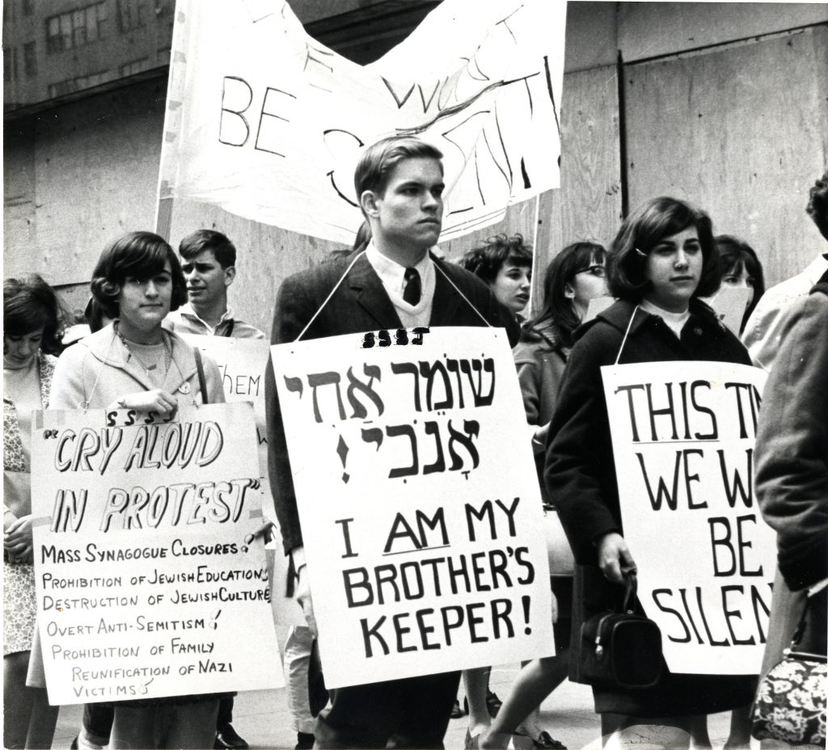](https://jewishaction.com/content/uploads/2021/11/Birnbaum2-scaled.jpg)**

**A group of Yeshiva University students from the Student Struggle for Soviet Jewry (SSSJ) attending a protest in the 1960s. Courtesy of Yeshiva University Archives**

Birnbaum’s multi-pronged approach, which called for mobilizing people to champion the cause, running daily campaigns using contemporary civil rights protest tactics and pressuring Washington to take action, are detailed in a 2017 Russian American Jewish Experience (RAJE) video (https://www.youtube.com/watch?v=CmV2Ismz9Bg). (RAJE addresses the Jewish communal and educational needs of young Russian American Jews.)

In addition to doing his best to capture media attention, Birnbaum was also hoping to let the Soviet Union’s three million Jews know they weren’t being forgotten.

Birnbaum’s strategies may seem typical today, but at the time they were groundbreaking. Using key phrases like “Let my people go” and Biblical images with universal recognition, he sparked a movement that left American Jews feeling responsible for their Soviet counterparts.

**First Rally Scheduled for May Day**

At SSSJ’s first rally, timed to coincide with the Soviet holiday of May Day, 1,000 students demonstrated in total silence for four hours across from the Soviet Union’s mission to the United Nations, the eerie quiet paying homage to Soviet Jewry’s forced silence.1

SSSJ remained at the forefront of the Soviet Jewry movement for years, with a single-minded focus of freeing all those who remained trapped behind the Iron Curtain. Even as it became a global cause, with others taking the lead in many areas, Birnbaum remained SSSJ’s heart and soul, steering its vision and staying in close contact with community leaders and elected officials.

**The Power of a Small Group**

Seeing how a small group of students ultimately altered the course of Jewish history was a dream come true for Birnbaum, with American Jewry realizing for the first time that it had the power to take on causes and enact positive change.

Rabbi Guttentag describes his uncle as an idealist, someone who kept his head down and did whatever he could to help others throughout his life. “Even in the final years of his life, he would agonize over the hardships that were affecting local families, and you could see his pain when he heard of families in Eretz Yisrael going through challenges,” says Rabbi Guttentag. “That was his lev tov, his good heart, in the macro and the micro.”

**Note**

1. Yossi Klein Halevi, “Jacob Birnbaum and the Struggle for Soviet Jewry,” AzureOnline, 17 (spring 2004).

*Reprinted from the Winter 2021 edition of the Jewish Action.* Sandy Eller is a writer for numerous websites, newspapers, magazines and private clients.

**The Dangers of Wealth**

**By Rabbi Eli Mansour**



Before Benei Yisrael left Egypt, G-d tells Moshe, "Please speak to the nation that they should each borrow from his fellow…silver and gold utensils" (Shemot 11:2). Moshe is to instruct the people to borrow property from their Egyptian neighbors which they will take with them as they leave Egypt.

After over two centuries of slave labor, it was time for Benei Yisrael to receive their due payment from the Egyptians, and G-d therefore bid them to go to their neighbors who, He assured them, would happily give them their money and possessions.

**The Seeming Peculiarity of the Word “Na”/Please**

Many commentators noted the seemingly peculiar word "Na" – "please" – in this verse. It sounds as though Moshe had to plead with the people to borrow their neighbors' possessions. Why would have to plead? Wouldn't the people relish the opportunity to seize the wealth of their former oppressors?

Furthermore, why did G-d have Benei Yisrael seize the Egyptians' wealth in this manner, by asking to "borrow" their possessions? Moshe had already brought nine devastating plagues upon Egypt; the Egyptians were already intimidated. Would they have refused Benei Yisrael's request that they give them gold and silver utensils? Why didn't they ask in a more straightforward manner?

One explanation is that Benei Yisrael feared the consequences of acquiring wealth. This marked the first time that Benei Yisrael as a nation became affluent, and they perceptively understood the spiritual challenges that affluence poses. Wealth is a privilege and a blessing, but it can often lead to arrogance and conceit. Affluent people often regard themselves with greater importance than others, and assume the right to force their will upon the less privileged and to exert control and power. To Benei Yisrael's credit, they initially hesitated when the time came to seize the property of Egypt; they feared the potential impact that their newfound position of affluence might have upon their characters and souls.

Moshe therefore had to plead with them to obey G-d's command and take their neighbors' possessions. But how did Benei Yisrael protect themselves from the arrogance and egotism that often results from affluence? How did Moshe assuage their legitimate concerns? Moshe advised the people to borrow, rather than just ask to keep, their neighbors' possessions.

A person who borrows expensive items cannot feel pride over what he has, because he knows it does not belong to him. If a person rents a luxury car, he can't show it off or gloat, because he will soon have to return it. This was the solution to Benei Yisrael's ambivalence towards their acquisition of wealth. And this is the proper response to the challenge of wealth generally: to look upon what a person has as borrowed goods.

When a person realizes that money has wings, that all his wealth could be taken from him at any time, his ego is tempered; he cannot feel too proud or confident. This is the proper perspective with which to look upon one's possessions: as borrowed goods. Nothing in life is guaranteed, and there is no telling when our belongings will be taken from us. This perspective will help us avoid the pitfalls of wealth, and maintain the proper sense of humility even as we enjoy the comforts and luxuries of American society.

*Reprinted from the Parshat Bo 5782 edition of iTorah.com*

**Thoughts that Count**

**For Our Parsha**

*And it was told to the King of Egypt that the people fled; Pharoah and his servants had a change of heart* (Exod. 14:5)

We know that the Jews did not flee, they were sent away. The people the Torah is referring to were a group of Egyptians that Pharoah had sent with the Jews to make sure that the Jews would return to Egypt. Suddenly, Pharoah received word that his own people whom he had sent along with the Jewish people had fled. *(Ohr Hachaim)*

*Miriam the prophetess, the sister of Aharon, took the tambourine in her hand* (Exod. 15:20)

It does not say that Miriam took a tambourine, but that she took the tambourine, a specific tambourine. Years before, when Pharoah had decreed that baby boys should be drowned, Miriam's father divorced his wife so they would not have any more children. Miriam implored her father to remarry her mother, and prophesied that her mother would give birth to a son who would redeem the Jewish people. Her parents remarried, and throughout the years Miriam cherished the tambourine with which she had danced at the wedding. This was the tambourine she took after the splitting of the Sea.,*(Rav Mendel Alperin)*

*And the children of Israel ate the manna for forty years* (Exod. 16:35)

Since G-d provided the Jews with everything they needed, such as food and clothing, it seems impossible for them to have fulfilled the mitzva of charity. The manna in the dessert tasted like any food a person had in mind. A poor person had never tasted expensive foods, so the charity of a rich person was to recommend to a person which foods to have in mind. *(The Lubavitcher Rebbe)*

And he said, "The hand upon the throne of G-d; G-d maintains war against Amalek from generation to generation." (Exod. 17:16)

After the Jews left Egypt, they were on the highest level of faith in G-d. Amalek's attack on the Jewish people was not merely intended to destroy them physically, but to detach them from G-d spiritually, by putting doubts in their mind about G-d.

Whenever a Jew has doubts about Judaism, Amalek is at work. G-d is so angry at Amalek that He wants to wipe out his remembrance entirely.*(Keter Shem Tov).*

*Reprinted from the Parshat Beshalach 5757/1997 edition of L’Chaim. Adapted from Vedibarta Bam by Rabbi Moshe Bogomilsky.*

*\*\*\*\*\*\*\*\*\*\*\*\*\*\*\*\*\*\*\*\*\*\*\*\*\*\*\*\*\*\*\*\*\*\*\*\*\*\*\*\*\*\*\*\*\*\*\*\*\*\*\*\*\*\*\*\*\*\*\*\*\*\*\*\*\*\**

*And the Children of Israel walked upon dry land in the midst of the sea*. People are impressed only when they see events which are truly "miraculous". They fail to realize that nature itself is a great miracle, in which they can behold Hashem's greatness each day. (Rabbi Elimelech of Lizensk)

*Reprinted from the Parshat Beshalach 5782 email of Reb Yedidye Hirtenfeld’s whY I Matter newsletter for the Young Israel of Midwood in Brooklyn.*